The Office Management System

SUBJECT: DataBase
Instructor Name:
Zeeshan Saleem Sahib
Ehsan Malik Sahib

SUBMITTED BY:
Muhammad Fahad Malik

Overview:
The Office Management System is simple system and part of capstone project and wrap all actions and queries which I have to learn in module 5 of data analysis course. Module 5 is about structured Query Language
Objectives:
Objective is to design a simple system of office management and there will be two tables one for employee and other for departments with specific attributes. Create tables and relate these tables with foreign key. Employees Table will contain foreign keys which make relation with department table after that perform some basic operations to retrieve data.
1. SQL file of queries:
Here is the SQL file containing queries of my project:
1. SQL Queries screenshots:
Here is the complete project queries screenshots with details of project and queries.

1. Employees Table

This table keeps track of all the important details about each employee in the company.
- EmployeeID
- Name
- Rank
- Phone
- Salary
- ManagerID
- DepartmentID
Query:
-- First of all we have to create database
create database OfficeManagementSystem
-- After creating database you have to use database
use OfficeManagementSystem
Now we are creating desired tables
-- Create Employees table
CREATE TABLE Employees(
EmployeeID int primary key,
Name varchar(100) not null,
Rank varchar(10),
Phone varchar(12),
Salary decimal(10,2),
ManagerID int null,
DepartmentID int,
foreign key (DepartmentID) references Departments(DeptID),
foreign key (ManagerID) references Employees(EmployeeID)
);

2. Departments Table
The Departments table stores basic information about each department in the company:
- DeptID
- DeptName
Query:
-- Create Departments table
create table Departments(
DeptID int primary key,
DeptName varchar(50) not Null);

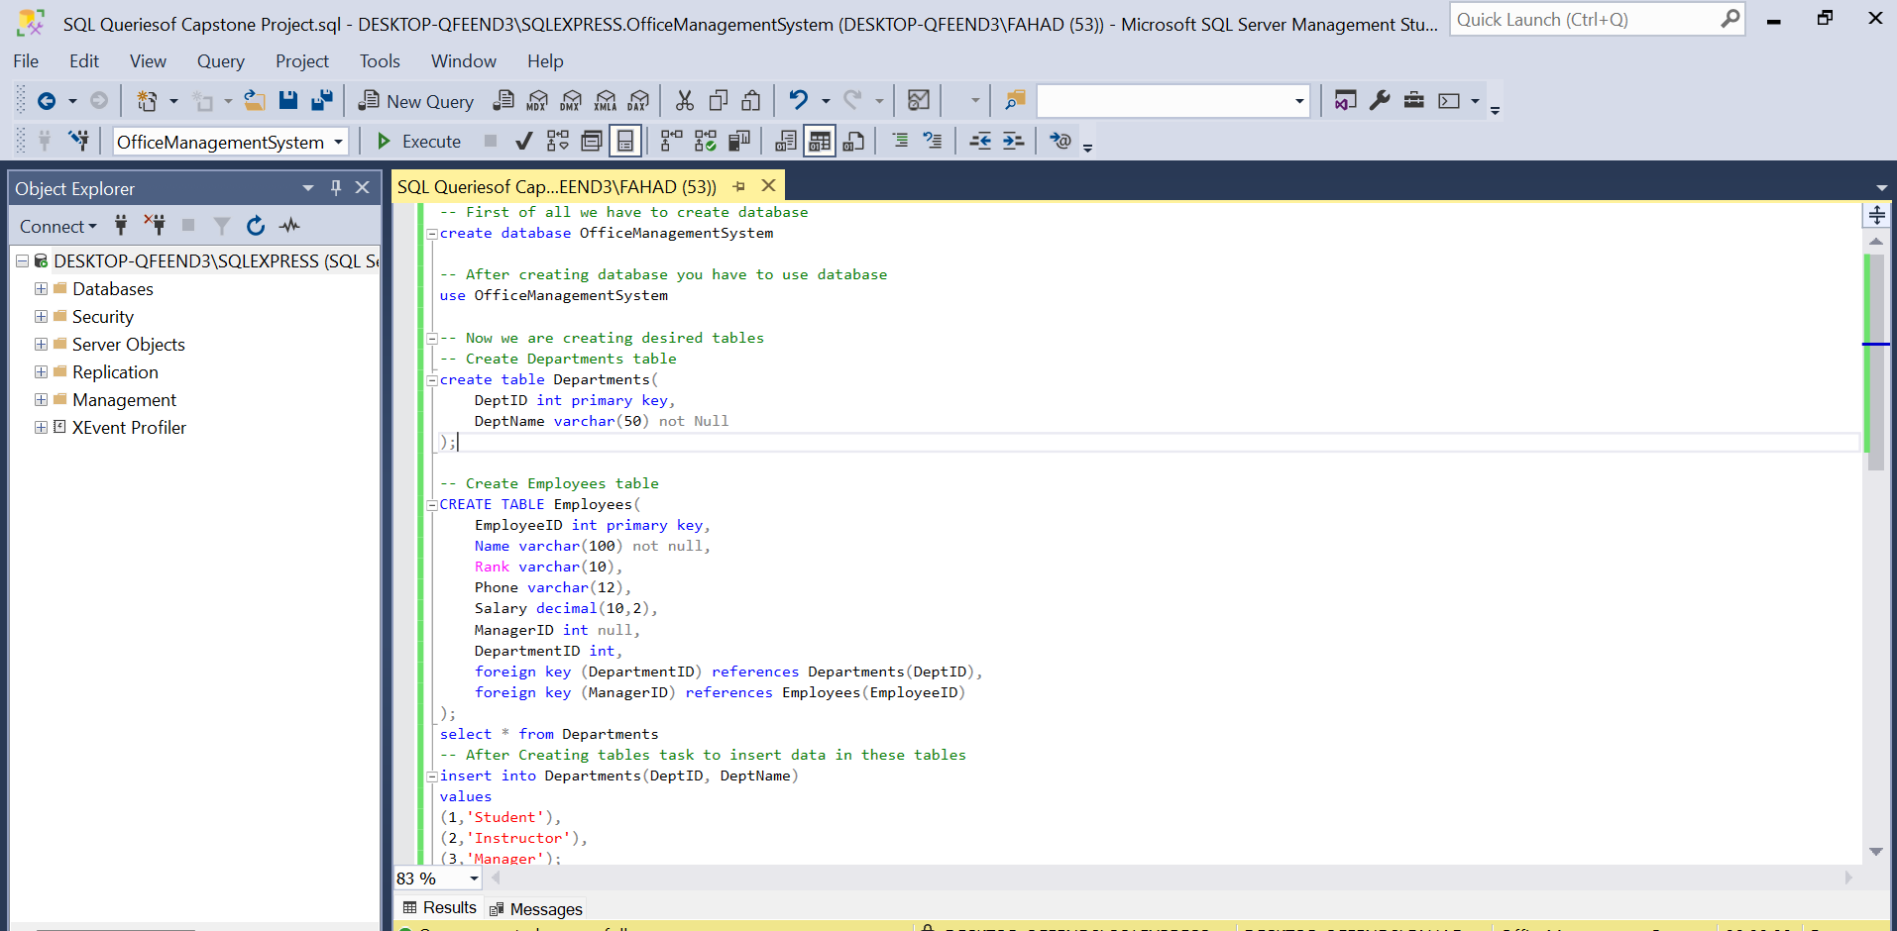

Questions:
- Write SQL statements to create the Employee and Department table.
- Insert the sample data at least 5-Employees and 3-Departments in the relevant tables. Make sure the data of the employee is about instructors in this Data Analytics batch (Zeeshan Saleem, Ehsan Malik, Mam Aleena,Me Muhammad Fahad Malik) and include yourself also as ‘Student’. As for the managerID, use any instructor as your manager and all instructors must have Ali as Manager. While Ali has no manager.
- Write a SQL query to get Employee name, Department Name, Manager Name using Joins.
- Write an SQL query to sum the salary for each department using the SUM function and the GROUP BY clause.
Queries:
-- After Creating tables task to insert data in these tables
insert into Departments (DeptID, DeptName)
values
(1,'Student'),
(2,'Instructor'),
(3,'Manager');

insert into Employees (EmployeeID, Name, Rank, Phone, Salary, ManagerID, DepartmentID)
VALUES
(101,'Ali','Manager','03051032650',200000, NULL, 3 ) -- Manager has no manager that's why this field is null
(102,'Zeeshan Saleem','Instructor','03017518315',180000,101,2),
(103,'Ehsan Malik','Instructor','03023334455',15000,101,2),
(104,'Mam Aleena','Instructor','03036369775',120000,101,2),
(105,'Muhammad Fahad Malik','Student','03432173332',30000,102,1); -- Student at paid internship that's why salary is 30000
Select * from Employees
Select * from Departments
-- Now next task is to perform basic operations which are given in task
-- Retrieve data Employee name, department name and Manager name using joins
select e.Name as EmployeeName,d.DeptName as DepartmentName,m.Name as ManagerName
from Employees e left join Departments d on e.DepartmentID=d.DeptID
left join Employees m on e.ManagerID=m.EmployeeID;

-- sum the salary for each department using the SUM function and the GROUP BY clause
select d.DeptName as DepartmentName,sum(e.Salary) as TotalSalary from Employees e
join Departments d on e.DepartmentID=d.DeptID group by d.DeptName;

Tables Output Image:
This image will show about that tables are created and data is inserted in tables successfully.
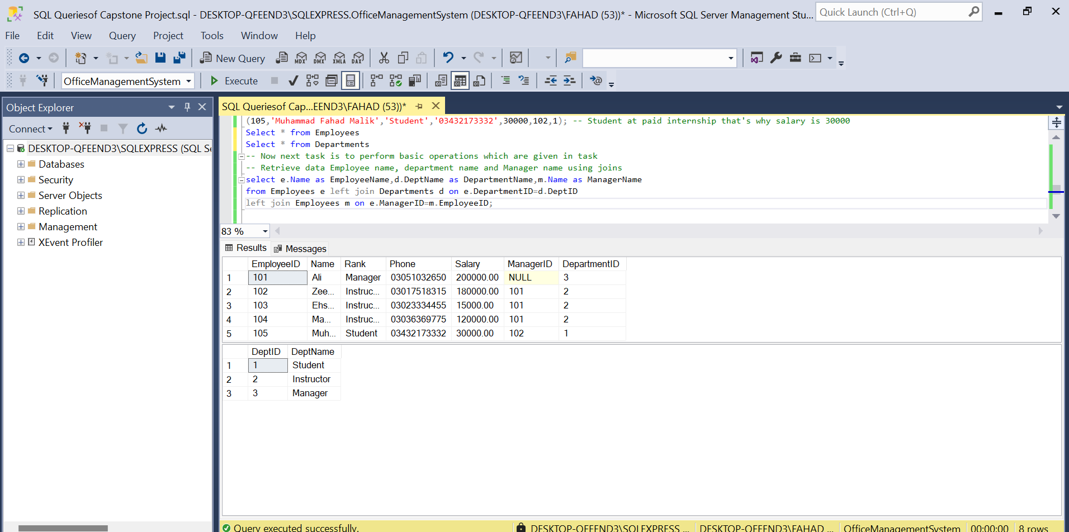

First Task Output Image:
This image will show about get Employee name, Department Name, Manager Name using Joins.
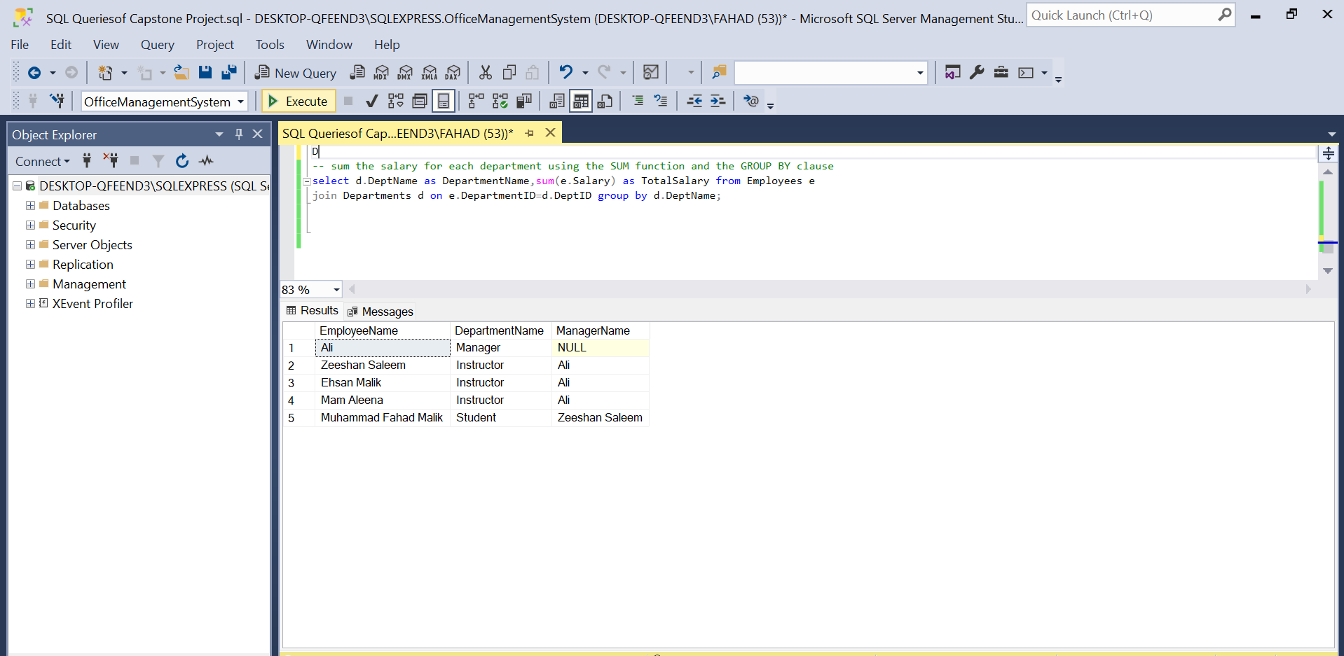

Second Task Output Image:
This image will show about sum the salary for each department using the SUM function and the GROUP BY clause.

